|  |  |  |  |
| --- | --- | --- | --- |
|  | | | |
|  | Practical FileComputer Science(Class XI) |  |

|  |  |
| --- | --- |
| Submitted To  Mr. A.K. Mishra  Headmaster Sr. Sch. | Submitted By  Gayatri P  XI Sci |

# Python

# Assignment 1

***Objective****:* Write a python program to read today’s date from user. Then display how many days are left in current days.

***Code***:

date=input("Enter date in DDMMYYYY format :")

month=date[2:4]

if month in ("01", "03", "05", "07", "08", "10", "12"):

    left=31-int(date[0:2])

elif month in ("04", "06", "09", "11"):

    left=30-int(date[0:2])

if month=="02":

    if int(date[4:])%4==0:

        left=29-int(date[0:2])

    else:

        left=28-int(date[0:2])

print("Number of days left in month =",left)

***Input****:*

Enter date in DDMMYYYY format : 2908200*1*

***Output****:*

Number of days left in month = 2

***Input****:*

Enter date in DDMMYYYY format : 24112020

***Output****:*

Number of days left in month = 6

# Assignment 2

***Objective***: Write a python program to obtain x, y, z from users and calculate expression: 4x4+3y3+9z+6π.

***Code****:*

from math import pi

x=int(input("Enter value of x : "))

y=int(input("Enter value of y : "))

z=int(input("Enter value of z : "))

sol=(4*(x**4))+(3*(y**3)+(9*z)+(6*pi))

print("Solution of equation is",sol)

***Input****:*

Enter value of x : 3

Enter value of y : 6

Enter value of z : 9

***Output****:*

Solution of equation is 1071.849555921539

# Assignment 3

***Objective***: Write a python program that accepts marks in 5 subjects and outputs average marks.

***Code****:*

s1 = int(input("Enter marks in Physics : "))

s2 = int(input("Enter marks in Chemistry : "))

s3 = int(input("Enter marks in Maths : "))

s4 = int(input("Enter marks in Computer Science : "))

s5 = int(input("Enter marks in English : "))

avg=(s1+s2+s3+s4+s5)/5

print("Average of five subjects is", avg)

***Input****:*

Enter marks in Physics : 90

Enter marks in Chemistry : 96

Enter marks in Maths : 100

Enter marks in Computer Science : 100

Enter marks in English : 94

***Output****:*

Average of five subjects is 96.0

# Assignment 4

***Objective***: Write a python program to take a 2-digit number and then print the reversed number.

***Code****:*

n=int(input("Enter the no. for reversing : "))

rev=0

m=n

while n>0:

    s=n%10

    rev=rev*10+s

    n=n//10

print("Reverse of",m,"is",rev)

***Input****:*

Enter the no. for reversing : 23365

***Output****:*

Reverse of 23365 is 56332

***Input****:*

Enter the no. for reversing : 23452

***Output****:*

Reverse of 23452 is 25432

# Assignment 5

***Objective***: Write a python program to input a single digit (n) and print a three digit number created as <n(n+1)(n+2)>. The input digit is in range 1-7.

***Code****:*

dig=int(input("Enter a digit from 1-7 : "))

new_dig=str(dig)+str(dig+1)+str(dig+2)

print("New digit is",new_dig)

***Input****:*

Enter a digit from 1-7 : 1

***Output****:*

New digit is 123

***Input****:*

Enter a digit from 1-7 : 7

***Output****:*

New digit is 789

# Assignment 6

***Objective***: Write a python program to print first n odd numbers in descending order.

***Code****:*

n=int(input("Enter upper limit : "))

a=[]

for i in range(1,n+1,2):

    a.append(i)

a.reverse()

for i in a:

    print(i, end=" ")

***Input****:*

Enter upper limit : 28

***Output****:*

27 25 23 21 19 17 15 13 11 9 7 5 3

# Assignment 7

***Objective***: Write a python program to input length of three sides of a triangle. Then check if these sides will form a triangle or not.

***Code****:*

a=int(input("Enter first side : "))

b=int(input("Enter second side : "))

c=int(input("Enter third side : "))

if (a+b)>c and (b+c)>a and (a+c)>b:

    print("Triangle will be formed.")

else:

    print("Triangle will not be formed")

***Input****:*

Enter first side : 4

Enter second side : 5

Enter third side : 6

***Output****:*

Triangle will be formed.

***Input****:*

Enter first side : 1

Enter second side : 2

Enter third side : 7

***Output****:*

Triangle will not be formed.

# Assignment 8

***Objective***: Write a python program to print every integer between 1 and n divisible by m. Also, report whether the number divisible by m is odd or even.

***Code****:*

n=int(input("Enter upper limit : "))

m=int(input("Enter divisor : "))

a=[]

for i in range(1,n):

    if i%m==0 and i%2==0:

        print(i,"is divisible by",m,"and is even")

    elif i%m==0 and i%2!=0:

        print(i,"is divisible by",m,"and is odd")

***Input****:*

Enter upper limit : 18

Enter divisor : 4

***Output****:*

4 is divisible by 4 and is even

8 is divisible by 4 and is even

12 is divisible by 4 and is even

16 is divisible by 4 and is even

***Input****:*

Enter upper limit : 12

Enter divisor : 3

***Output****:*

3 is divisible by 3 and is odd

6 is divisible by 3 and is even

9 is divisible by 3 and is odd

12 is divisible by 3 and is even

# Assignment 9

***Objective***: Write a python program to sum the given sequence : 12 +32 +52 +…….+n2 (input n).

***Code****:*

n=int(input("Enter upper limit : "))

sum=0

for i in range(1,n+1,2):

    sum+=(i**2)

print("Sum is",sum)

***Input****:*

Enter upper limit : 15

***Output****:*

Sum is 680

***Input****:*

Enter upper limit : 24

***Output****:*

Sum is 2300

# Assignment 10

***Objective***: Ask the user to enter a list containing numbers between 1 and 12. Then replace all the entries in the list that are greater than 10 with 10

***Code****:*

nums=eval(input("Enter a list of numbers in the range 1 to 12 : "))

for i in range(len(nums)):

    if nums[i]>10:

        nums[i]=10

print("New list is",nums))

***Input****:*

Enter a list of numbers in the range 1 to 12 : [1,11,12,2,5,7,10,8,6,9,3,11,10,5,12]

***Output****:*

New list is [1, 10, 10, 2, 5, 7, 10, 8, 6, 9, 3, 10, 10, 5, 10]

# Assignment 11

***Objective***: Write a python program that reads a string and then prints a string that capitalizes every other letter in the string. E.g. passion becomes pAsSiOn.

***Code****:*

str=input("Enter a string : ")

len1=len(str)

list1=list(str)

for i in range(1,len1,2):

    list1[i]=list1[i].upper()

s=""

for i in list1:

    s+=i

print("New string is",s)

***Input****:*

Enter a string : passion

***Output****:*

New string is pAsSiOn

***Input****:*

Enter a string : python

***Output****:*

New string is pYtHoN

# Assignment 12

***Objective***: Write a python program that inputs a list of numbers and shifts all the zeros to the left and all non-zero numbers to the right of the list.

***Code****:*

list1=eval(input("Enter a list of numbers : "))   #not copied

list2=[]

for i in list1:

    if i==0:

        list2.insert(0, i)

    else:

        list2.append(i)

print("New list is",list2)

***Input****:*

Enter a list of numbers : [1, 2, 3, 0, 0, 5]

***Output****:*

New list is [0, 0, 1, 2, 3, 5]

***Input****:*

Enter a list of numbers : [1,0,12,0,5,7,10,8,6,0,3,11,0,5,12]

***Output****:*

New list is [0, 0, 0, 0, 1, 12, 5, 7, 10, 8, 6, 3, 11, 5, 12]

# Assignment 13

***Objective***: Write a program inputs two tuple and creates third, that contain all the elements of first followed by all the elements of the second, which are not in the first.

***Code****:*

a=eval(input("Enter first tuple : "))

b=eval(input("Enter second tuple : "))

c = []

c.extend(a)

for i in b:

    if i not in a:

        c.append(i)

print("New tuple is", tuple(c))

***Input****:*

Enter first tuple : (1, 2, 3, 4, 5, 6)

Enter second tuple : (4, 5, 6, 7, 8, 9)

***Output:***

New tuple is (1, 2, 3, 4, 5, 6, 7, 8, 9)

# Assignment 14

***Objective***: Write a python program that:

1. prompts the user for a string
2. Extract all the digits from the string
3. If there are digits, print the digits and the sum of the digits
4. If there are no digits, show a message stating the same.

***Code****:*

str1=input("Enter a string : ")

list1=[]

total=0

for i in str1:

    if i.isdigit():

        list1.append(i)

        total += int(i)

if total > 0:

    print('Digits in the string : ', end='')

    for i in list1:

        print(i, end=" ")

    print("\nSum of digits is", total)

else:

    print("Given string has no digits")

***Input****:*

Enter a string : 1.7wh1ter0se.m4v

***Output:***

Digits in the string : 1 7 1 0 4

Sum of digits is 13

***Input****:*

Enter a string : whiterose

***Output:***

Given string has no digits

# Assignment 15

***Objective***: Given a tuple pairs=((2,5),(4,2),(9,8),(12,10)), count the numbers of pair (a, b) such that both a and b are even.

***Code****:*

count=0

pairs=eval(input("Enter a tuple which contains a tuple of 2 numbers: "))

for i in pairs:

    a=list(i)

    if a[0]%2==0 and a[1]%2==0:

        count+=1

print(count)

***Input****:*

Enter a tuple which contains a tuple of 2 numbers: ((1,2),(4,5),(2,4),(6,8))

***Output:***

2

# Assignment 16

***Objective***: Find the sum of the sequence. $x+\frac{x^{2}}{2}+\frac{x^{3}}{3}….\frac{x^{n}}{n}$

***Code****:*

x=int(input("Enter value of x : "))

n=int(input("Enter upper limit : "))

sum=0

for i in range(1,n+1):

    sum+=((x**i)/i)

print("Sum is",sum)

***Input****:*

Enter value of x : 2

Enter upper limit : 2

***Output:***

Sum is 4.0

***Input****:*

Enter value of x : 1

Enter upper limit : 3

***Output:***

Sum is 1.8333333333333333

# Assignment 17

***Objective***: Write a python program that has a list containing the squares of the integers 1 through 50.

***Code****:*

list1=[i**2 for i in range(1, 51)]

print(list1)

***Output****:*

[1, 4, 9, 16, 25, 36, 49, 64, 81, 100, 121, 144, 169, 196, 225, 256, 289, 324, 361, 400, 441, 484, 529, 576, 625, 676, 729, 784, 841, 900, 961, 1024, 1089, 1156, 1225, 1296, 1369, 1444, 1521, 1600, 1681, 1764, 1849, 1936, 2025, 2116,

2209, 2304, 2401, 2500]

# Assignment 18

***Objective***: Write a python program to compute simple interest and compound interest.

***Code****:*

p=int(input("Enter Principal Amount : "))

r=int(input("Enter Rate of Interest (in %) : "))

t=int(input("Enter Time period (in years) : "))

simple_interest=(p*r*t)/100

print("Simple Interest for the given data is", simple_interest)

amt=p*((1+(r/100))**t)

compund_interest= round(amt-p, 2)

print("Compound Interest for the given data is", compund_interest)

***Input****:*

Enter Principal Amount : 1000

Enter Rate of Interest (in %) : 10

Enter Time period (in years) : 2

***Output****:*

Simple Interest for the given data is 200.0

Compound Interest for the given data is 210.0

# Assignment 19

***Objective***: Write a python program that has a list [‘a’,’bb’,’ccc’,’dddd’,…] that ends with 26 copies of the letter z.

***Code****:*

list1 = [chr(x)*(x-96) for x in range(97, 123)]

print(list1)

***Output****:*

['a', 'bb', 'ccc', 'dddd', 'eeeee', 'ffffff', 'ggggggg', 'hhhhhhhh', 'iiiiiiiii', 'jjjjjjjjjj', 'kkkkkkkkkkk', 'llllllllllll', 'mmmmmmmmmmmmm', 'nnnnnnnnnnnnnn', 'ooooooooooooooo', 'pppppppppppppppp', 'qqqqqqqqqqqqqqqqq', 'rrrrrrrrrrrrrrrrrr', 'sssssssssssssssssss', 'tttttttttttttttttttt', 'uuuuuuuuuuuuuuuuuuuuu', 'vvvvvvvvvvvvvvvvvvvvvv', 'wwwwwwwwwwwwwwwwwwwwwww', 'xxxxxxxxxxxxxxxxxxxxxxxx', 'yyyyyyyyyyyyyyyyyyyyyyyyy', 'zzzzzzzzzzzzzzzzzzzzzzzzzz']

# Assignment 20

***Objective***: Given a nested tuple [eg. t=((1,2),(3,4.15,5.15),(7,8,12,15))], write a program that displays the mean of individual elements of tuple tup1 and then displays the mean of the computed means.

***Code****:*

pairs=eval(input("Enter a tuple which contains a tuple of numbers : "))

means=[]

total=0

for tup in pairs:

    sum=0

    for i in tup:

        sum+=i

    mean=(sum/(len(tup)))

    print("Mean of", tup, "is", mean)

    means.append(mean)

for mean in means:

    total+=mean

mean=(total/(len(means)))

print("\nMean of means is",mean)

***Input****:*

Enter a tuple which contains a tuple of numbers : ((1,2,3),(4,5,9),(2,4,16,24),(60,80,76))

***Output:***

Mean of (1, 2, 3) is 2.0

Mean of (4, 5, 9) is 6.0

Mean of (2, 4, 16, 24) is 11.5

Mean of (60, 80, 76) is 72.0

Mean of means is 22.875

# Assignment 21

***Objective***: Write a python program to print the structure.

*

* *

* * *

* * * *

* * *

* *

*

***Code****:*

rows = 7

mid = int(rows/2)+1

for i in range(1, mid+1):

    for j in range(1, i+1):

        print('*', end=' ')

    print()

for i in range(mid+1):

    for j in range(0, mid-i-1):

        print('*', end=' ')

    print()

***Output****:*

*

* *

* * *

* * * *

* * *

* *

*

# Assignment 22

***Objective***: Write a python program to print the structure.

*

* *

* *

* *

* *

* *

*

***Code****:*

rows = 7

mid = int(rows/2)+1

print("*")

for i in range(1, mid):

    print("*"+i*"  "+"*")

for i in range(rows-mid-1,0,-1):

    print("*"+i*"  "+"*")

print("*")

***Output****:*

*

* *

* *

* *

* *

* *

*

# Assignment 23

***Objective***: Given the dictionary x= {k1’:’v1’,’k2’:’v2’,’k3’:’v3’}, create a list with the opposite mapping, i.e., write a program to create a dictionary as : {v1’:’k1’,’v2’:’k2’,’v3’:’k3’}

***Code****:*

dict1={"k1":"v1","k2":"v2","k3":"v3"}

dict2={}

for key, value in dict1.items():

    dict2[value] = key

print("Original Dictionary is",dict1)

print("Inverted Dictionary is",dict2)

***Output****:*

Original Dictionary is {'k1': 'v1', 'k2': 'v2', 'k3': 'v3'}

Inverted Dictionary is {'v1': 'k1', 'v2': 'k2', 'v3': 'k3'}

# Assignment 24

***Objective***: Given list of integers, write a python program to find those which are palindromes.

***Code****:*

list1=eval(input("Enter a list of numbers : "))

for i in list1:

    i = str(i)

    if i == i[::-1]:

        print(i,"is palindrome")

***Input****:*

Enter a list of numbers : [123, 456, 789, 121, 12345678987654321, 324423]

***Output****:*

121 is palindrome

12345678987654321 is palindrome

324423 is palindrome

# Assignment 25

***Objective***: Write a program to print a tuple containing first n terms of Fibonacci series.

***Code****:*

n = int(input('n = '))

a, b = 0, 1

fib = [a]

for i in range(n):

    fib.append(b)

    a, b = b, a+b

print(tuple(fib))

***Input****:*

n = 15

***Output****:*

(0, 1, 1, 2, 3, 5, 8, 13, 21, 34, 55, 89, 144, 233, 377, 610)

# Assignment 26

***Objective***: Write a program to print a given string in the following way.

a f

b i

c h

d g

e f

***Code****:*

l = input('Enter a string: ')

n = int(len(l) / 2)

j = n-1

for i in range(1, n+1):

    print(' '*(i-1) + l[i-1] + ' '*(2*j+1) + l[-i])

    j -= 1

if len(l) % 2 == 1:

    print(' '*(n) + l[n])

***Input****:*

Enter a string: kingdomcome

***Output****:*

k e

i m

n o

g c

d m

o

***Input****:*

Enter a string: darkinside

***Output****:*

d e

a d

r i

k s

i n

# Assignment 27

***Objective***: Write a program that, from two dictionaries, prints the keys which have same values, along with the value.

***Code****:*

d1 = eval(input('Enter dict 1: '))

d2 = eval(input('Enter dict 2: '))

d3 = {y: x for x, y in d2.items()}

for k1, val in d1.items():

    if val in d2.values():

        key_in_d2 = d3[val]

        print(f'{k1} and {key_in_d2} have the same value {val}')

***Input:***

Enter dict 1: {1: 'a', 2: 'b', 3: 'c', 7: 'e'}

Enter dict 2: {4: 'd', 5: 'b', 6: 'c', 8: 'f'}

***Output****:*

2 and 5 have the same value b

3 and 6 have the same value c

# Assignment 28

***Objective***: Repeatedly ask the user to enter the team name and how many games the team has won and how many they lost. Store this information in a dictionary where the keys are the team names and the values are lists of the form [wins, losses].

(a) Using the dictionary created above, allow the user to enter a team name and print out the team’s winning percentage.

(b) Using the dictionary, show all those teams that have winning records.

***Code****:*

teams={}

tnum=int(input("Enter number of teams : "))

for i in range(tnum): # adding data

    tname=input("Enter a team name : ")

    wins=int(input("Enter number of matches won : "))

    losses=int(input("Enter number of matches lost : "))

    teams[tname]=[wins,losses]

# printing collected data

print('\nTeam data')

print(teams)

# (a) Get winnig percentage

tnuser=input("\nEnter a team\'s name from the list above :")

x = teams.get(tnuser)

perc = round((x[0]*100)/sum(x), 2)

print(f'Win percentage of {tnuser} is {perc}%\n')

# (b) teams that have winning records

print('Teams with winning records: ')

for key, value in teams.items():

    if value[0] > value[1]:

        print(f'{key} with {value[0]} wins')

***Output****:*

Enter number of teams : 3

Enter a team name : lksec

Enter number of matches won : 10

Enter number of matches lost : 2

Enter a team name : mayo

Enter number of matches won : 6

Enter number of matches lost : 8

Enter a team name : modern

Enter number of matches won : 9

Enter number of matches lost : 7

Team data

{"lksec": [10, 2], "mayo": [6, 8], "modern": [9, 7]}

Enter a team's name from the list above :lksec

Win percentage of lksec is 83.33%

Teams with winning records:

lksec with 10 wins

modern with 9 wins

# Assignment 29

***Objective***: Write a python program to input a string and returns two strings, one containg original string's values at odd index values and other containing original string's values at even index values.

***Code****:*

string=input("Enter string : ")

a, b = '', ''

for i in range(len(string)):

    if i%2 == 0:

        a += string[i]

    else:

        b += string [i]

print("values at odd index =",a)

print("values at even index =",b)

***Input****:*

Enter string : bohemian

***Output****:*

values at odd index = bhma

values at even index = oein

# Assignment 30

***Objective***: Write a program that reads a line and a substring. It should then display the number of occurrence of given substring in the line.

***Code****:*

line=input("Enter a line: ")

sub=input("Enter a substring: ")

end=len(line)

lensub=len(sub)

start=0

count=0

while start<end:

    pos=line.find(sub,start,end)

    if pos!=-1:

        count+=1

        start=lensub+pos

    else:

        break

    if start>=end:

        break

print(f'Number of occurences = {count}')

***Input****:*

Enter a line: there are so many people in house, so many that one will wonder how so many are there

Enter a substring: so

***Output:***

Number of occurences = 3

# MySQL

**TABLE: gym**

|  |  |  |  |
| --- | --- | --- | --- |
| **ICODE** | **INAME** | **PRICE** | **BRANDNAME** |
| G101 | Power Fit Exerciser | 20000 | Power Gymea |
| G102 | Aquafit Hand Grip | 1800 | Reliable |
| G103 | Cycle Bike | 14000 | Ecobike |
| G104 | Protoner Extreme Gym | 30000 | Coscore |
| G105 | Message Belt | 5000 | Message Expert |
| G106 | Cross Trainer | 13000 | GTC Fitness |

# Assignment 31

***Objective***: Write SQL code to create the above table with the following constaints:

* ICODE – PRIMARY KEY
* INAME – NOT NULL
* PRICE – should be > 500

***Code****:*

CREATE TABLE test(

icode CHAR(4) PRIMARY KEY,

iname VARCHAR(20) NOT NULL,

price int CHECK (price > 500),

brandname VARCHAR(20)

);

DESC gym;

***Table Description****:*

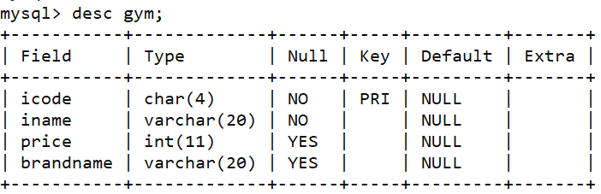

# Assignment 32

***Objective***: Write SQL code to insert the given values into the table.

***Code****:*

insert into gym values('G101','Power Fit Exerciser',20000,'Power Gymea')

insert into gym values('G102','Aquafit Hand Grip',1800,'Reliable')

insert into gym values('G103','Cycle Bike', 14000,'Ecobike')

insert into gym values('G104','Protoner Extreme Gym',30000  ,'Coscore')

insert into gym values('G105','Message Belt ',5000,'Message Expert')

insert into gym values('G106','Cross Trainer',13000,'GTC Fitness')

SELECT * FROM gym;

***Table****:*

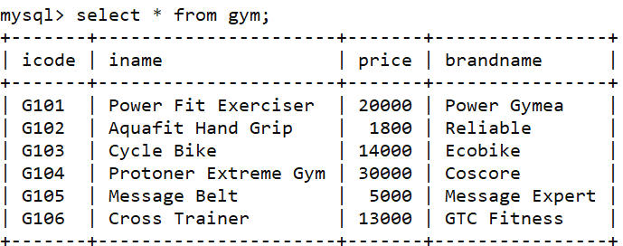

# Assignment 33

***Objective***: Write SQL code to to do the following:

1. display the names of all the items whose name starts with "A"

***Code****:*

SELECT iname FROM gym WHERE iname LIKE 'A%';

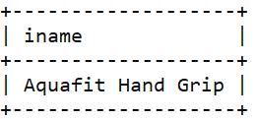***Output****:*

1. Write SQL code to display ICODEs and INAMEs of all items, whose Brandname is Reliable or Coscore.

***Code****:*

SELECT iname FROM gym WHERE iname LIKE 'A%';

***Output****:*

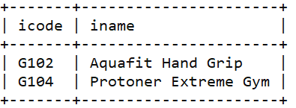

# 

# Assignment 34

***Objective***: Write SQL code to change the Brandname to "Fit Trend India" of the item, whose ICODE as "G101".

***Code****:*

update gym

set brandname='Fit Trend India'

where icode='g101';

select * from gym where icode='g101';

***Table****:*

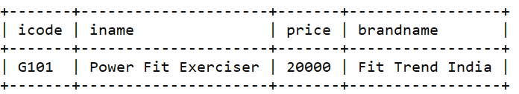

# Assignment 35

***Objective***: Select iname, icode, brandname and arrange them in order of expensive to cheaper.

***Code****:*

select * from gym

order by price desc;

***Table****:*

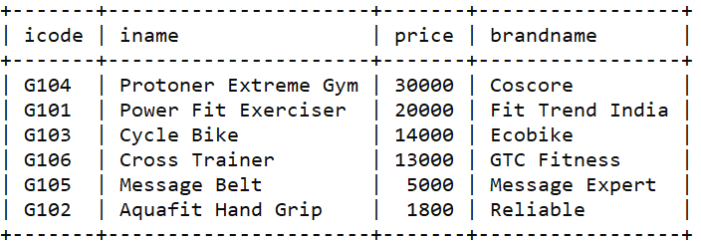

|  |  |  |  |  |  |  |
| --- | --- | --- | --- | --- | --- | --- |
| **COACH_ID** | **COACHNAME** | **AGE** | **SPORTS** | **DATOFAPP** | **PAY** | **SEX** |
| 1 | KUKREJA | 35 | KARATE | 27/03/1996 | 1000 | M |
| 2 | RAVINA | 34 | KARATE | 20/01/1998 | 1200 | F |
| 3 | KARAN | 34 | SQUASH | 19/02/1998 | 2000 | M |
| 4 | TARUN | 33 | BASKETBALL | 01/01/1998 | 1500 | M |
| 5 | ZUBIN | 36 | SWIMMING | 12/01/1998 | 750 | M |
| 6 | KETAKI | 36 | SWIMMING | 24/02/1998 | 800 | F |
| 7 | ANKITA | 39 | SQUASH | 20/02/1998 | 2200 | F |
| 8 | ZAREEN | 37 | KARATE | 22/02/1998 | 1100 | F |
| 9 | KUSH | 41 | SWIMMING | 13/01/1998 | 900 | M |
| 10 | SHAILYA | 37 | BASKETBALL | 19/02/1998 | 1700 | M |

**TABLE: club**

# Assignment 36

***Objective***: Write SQL code to create the above table.

***Code****:*

create table club(

coach_id int primary key,

coach_name varchar(20),

age int,

sports varchar(20),

date_of_app date,

pay int,

sex char(1) check (sex in ('F', 'M'))

);

DESC club;

***Table****:*

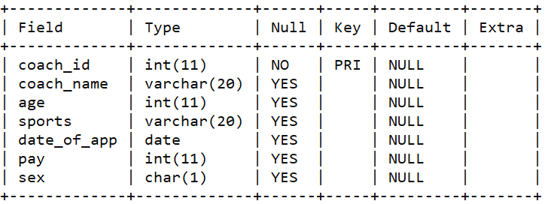

# Assignment 37

***Objective***: Write SQL code to show all information about the swimming coaches in the club.

***Code****:*

select * from club

where sports='SWIMMING';

***Table****:*

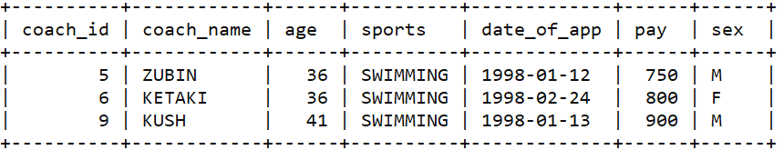

# Assignment 38

***Objective***: Write SQL code to list names of all coaches with their date of appointment (DATE_OF_APP) in descending order.

***Code****:*

select coach_name, date_of_app

from club

order by date_of_app desc;

***Table****:*

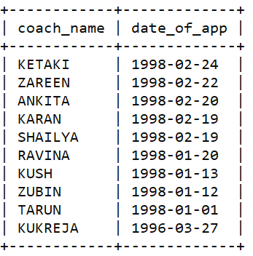

# Assignment 39

***Objective***: Write SQL code to :-

1. Display a report, showing coachname, pay, age and bonus(15% of pay) for all the coaches.

***Code****:*

select coach_name, pay, age, (15/100)*pay "bonus"

from club;

***Table****:*

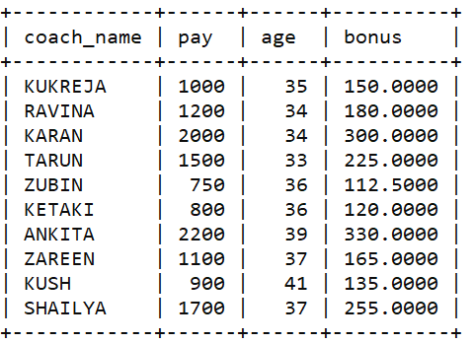

1. Increase the salary of coaches by 25% whose DATE_OF_APP is till 31st January,1998.

***Code:***

update club

set pay = pay+(25/100)*pay

where date_of_app < '1998-01-31';

***Table Before****:*

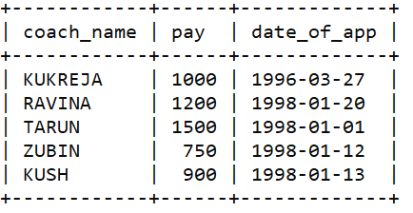

***Table After****:*

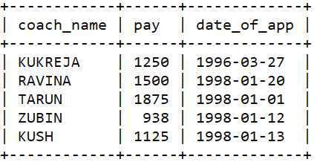

# Assignment 40

***Objective***: Write SQL code to display the names of all the coaches whose length of name is 6.

***Code****:*

select coach_name

from club

where coach_name like '______';

***Table****:*

